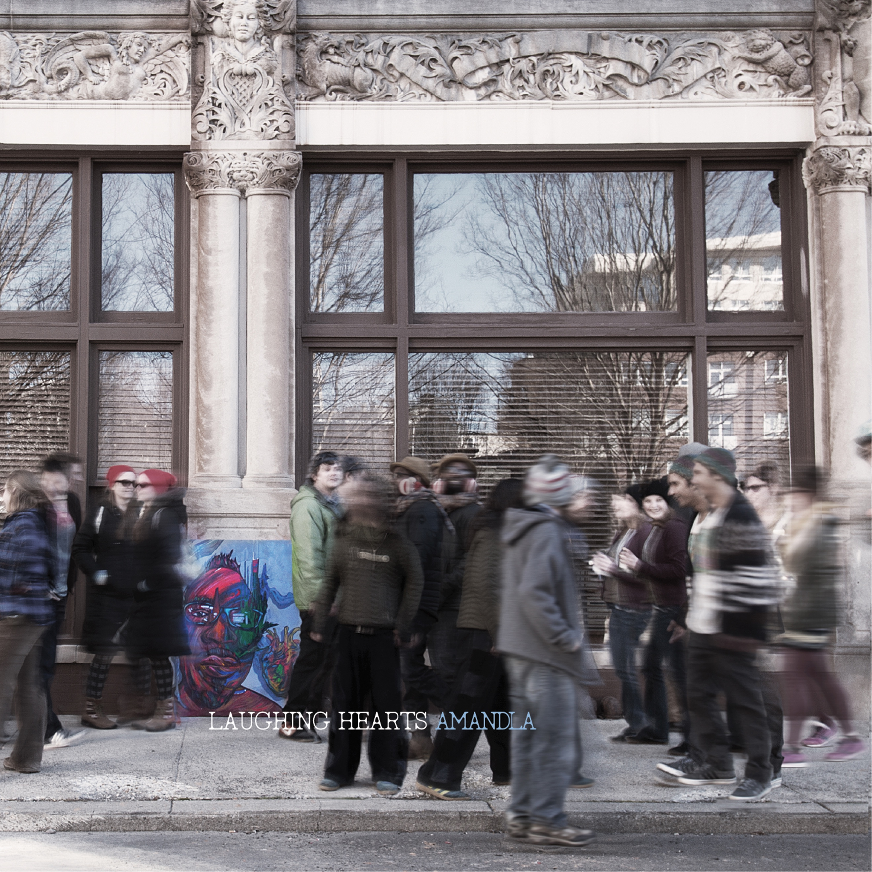 | LAUGHING HEARTS
Management: Jess Cross - jesscross13@gmail.com
Claude Coleman, Jr – claude@colemanjr.net
www.amandlanet.net

FOR IMMEDIATE RELEASE: WEEN DRUMMER CLAUDE COLEMAN JR RELEASES NEW RECORD ON VINYL AND DEVELOPS THE FIRST MUSIC PRACTICE SPACE IN ASHEVILLE, NC IN AN AFRICAN-AMERICAN MUSIC LANDMARK

"Coleman’s songwriting walks a tightrope between the heady vibe of jam/electronica and the indelible hooks of ’70s soul and even ’80s power pop" - Mountain XPress - Laughing Hearts Review

Fusing soul-rock, folk psychedelia, and an alternative R & B sound, Claude Coleman, Jr, the 25 years and still going drummer veteran of Ween, keeps true to his broad universe of influences on amandla's stunning new and third release, Laughing Hearts, now available on vinyl on his imprint, Marshall Hotel Records.

Laughing Hearts follows The Full Catastrophe, a record bridging the pop sounds of Squeeze, jazz rock and folk psychedelia, and reviewed as a ‘minor masterpiece’, and was completed after a near-fatal car accident. Much like its predecessor The Full Catastrophe - reviewed as 'a minor masterpiece' - Laughing Hearts was created during a period of personal collapse followed by relocation, resettling and regrowth. It is the portrayal of journeys and landscapes, and the discoveries of new truths. Recorded in studios across the country, Laughing Hearts includes special guests such as Kirk Kirkwood and Mike Dillon. The record has garnered raving early reviews, and is perhaps the most potent amandla release yet.

amandla brings the music of Laughing Hearts to Denver, CO June 5 and June 6 at Globe Hall, for a two-night run of after-shows following Ween at Red Rocks. Amandla will be performing local and national tour dates starting in July. It has so far done co-headlining tours with Dean Ween Group, and Mike Dillon Band, and will performing co-headlining shows with Angelo Moore of Fishbone, and his project Brand New Step. In addition further tour dates will be announced throughout the year, and amandla will be announcing a booking agency signing shortly. Laughing Hearts has just been released on vinyl.

amandla will be launching spring/summer touring in and around Ween, as Coleman completes development on the first music practice space facility in his city of Asheville, NC, called SoundSpace. SoundSpace will be a redeveloped property that was once a legendary soul-food kitchen for five generations, and a motel that used to provide lodging for Black music legends passing through Asheville on the 'Chitlin Circuit', such as Duke Ellington an Count Basie. Another soul-food kitchen is being brought back in - also to be the only in Asheville - and murals will be painted on the buildings depicting it's place in history. This project will provide a desperately resource for the music-dominated city as well as create an important landmark for the city and for the history of its African-American Community.

FOR PROMO REQUESTS / INTERVIEWS PLEASE CONTACT:
Management: Jess Cross - jesscross13@gmail.com
Claude Coleman, Jr – claude@colemanjr.net
www.amandlanet.net

